McNeil Invitational
Saturday September 28th,, 2017
Location: Old settlers Park
3300 E Palm Valley Blvd
Round Rock, Tx 78665

Packing List:

Racing Shorts
Racing singlet
running shoes & extra socks
Racing spikes/flats
Water bottle
Extra shirt

Departure Time:
VARSITY TEAMS
6:15 - Arrive at Westlake
6:20 – Depart from Westlake
JV & Freshmen
9:30 – Arrive at Westlake
9:45 – Depart from Westlake- 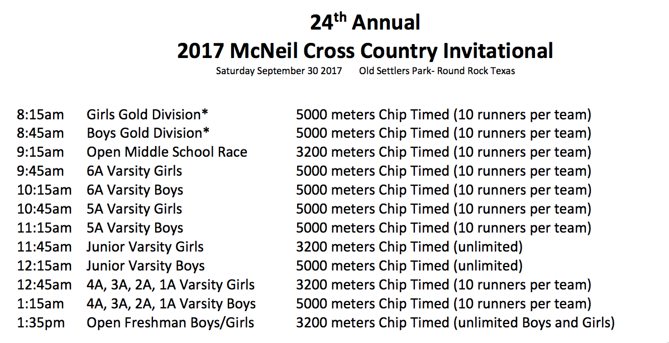

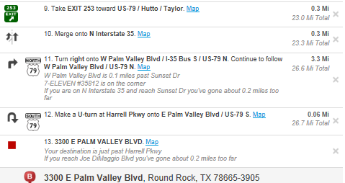
Directions: 