DISTRICT XC MEET
Tuesday October 10th, 2017
Location: Old settlers Park
3300 E Palm Valley Blvd
Round Rock, Tx 78665

Packing List:

Racing Shorts
Racing singlet
running shoes & extra socks
Racing spikes/flats
Water bottle
Extra shirt

$ for lunch

Time Schedule:
6:00 – Arrive at Westlake
6:10 – Depart from Westlake
8:00 – Varsity Girls Race – 5k
8:30 – Varsity Boys Race – 5k
9:00 – JVG Race – 5k
9:30 – JVB Race – 5k
10:00 – FG Race – 5k
10:30 – FB Race – 5k
11:15 – Awards Ceremony

We will stop for lunch after the meet.
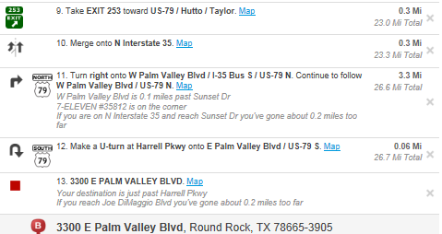
Directions: 