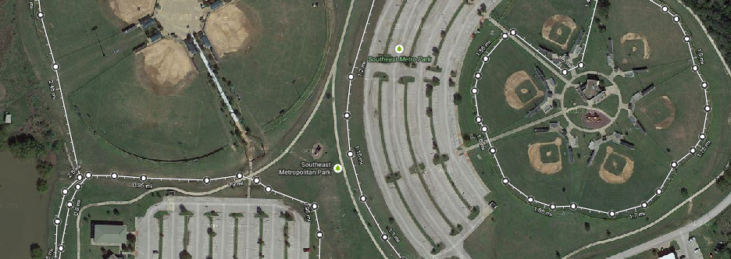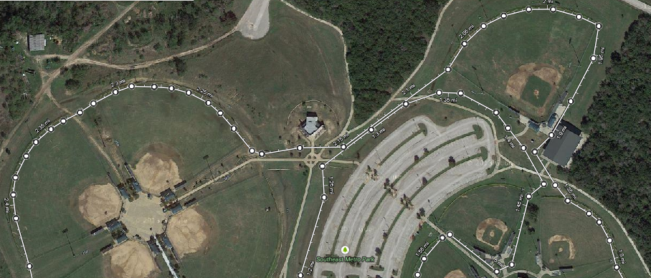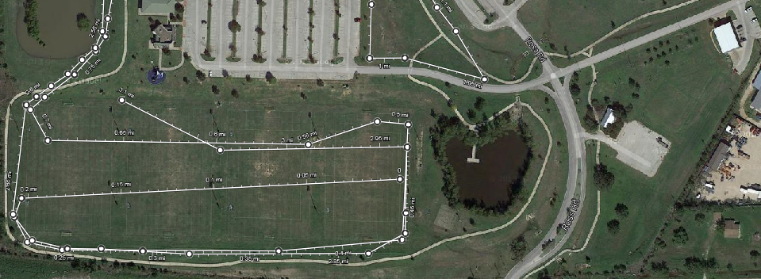**2017 CHAP INVITATIONAL – 5k**

**Finish**

**START**



**Mile 2**

**Mile 1**

