2 Mile Time Trial – Friday August 12th
Time Schedule:
- Depart from WHS @ 6:30

- Arrive at Brushy Creek Lake @ 7:00

- 3000m time trial - 2 x 1500m loops

- Girls 7:30
- Boys 8:00

- Depart from Brushy Creek Park – 9:15
- Arrive at WHS & unload & clean the bus – 10:00

What to bring:
- Race clothing
- 2nd set of clothes / socks
- Water bottle
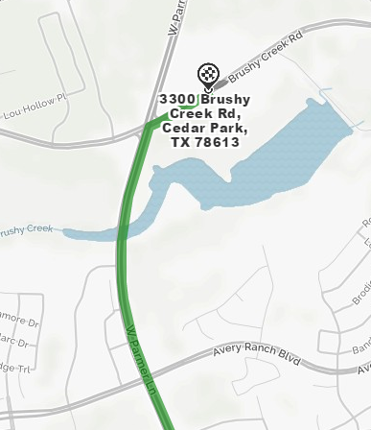
- Please do not wear spikes - flats or training shoes are ideal for the course

Westlake High School - 3300 Brushy Creek Rd, Cedar Park, TX 78613
27MIN - 22.1MI
- 2. Turn slight right onto S Capital of Texas Hwy/TX-360. – 10.7 mi
- 3. Turn left onto Research Blvd. - 10.79 total miles
- 4. Merge onto US-183 N via the ramp on the left. Then 6.24 miles17.03 total miles
- 5. Take the exit toward TX-45 E.
Then 1.04 miles18.07 total miles
- 6. Merge onto TX-45 E (Portions toll).
Then 0.48 miles18.56 total miles
- 7. Merge onto TX-45 E (Portions toll).
Then 0.45 miles19.01 total miles
- 8. Merge onto Ranch Road 620 N/RM-620 toward FM-734/Parmer Ln.
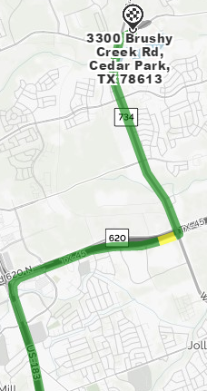
Then 0.56 miles19.57 total miles
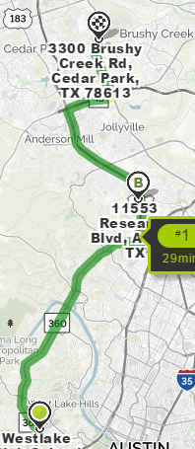
- 9. Turn left onto FM-734/W Parmer Ln.
  - If you are on Ranch Road 620 N and reach Ganzert Lake Rd you've gone about 0.1 miles too far
Then 2.35 miles21.93 total miles
- 10. Turn slight right onto Brushy Creek Rd.
  - Brushy Creek Rd is 0.6 miles past Avery Ranch Blvd
  - If you are on W Parmer Ln and reach Polar Ln you've gone about 0.6 miles too far
Then 0.19 miles22.12 total miles

11. 3300 BRUSHY CREEK RD is on the right.

