2018 – District Meet Travel Schedule

DISTRICT 25-6A TRACK AND FIELD CHAMPIONSHIPS WEDNESDAY APRIL 4, 2018. LEANDER HIGH SCHOOL
A.C. BIBLE STADIUM 3301 S. Bagdad Rd, Leander TX 78641

6:45 – Field Events & 3200m run arrive at WHS
7:00 – Depart for Leander HS
7:45 – Arrive at Leander HS

9:00AM - 3200M RUN – VG/VB/JVG/JVB/FG/FB
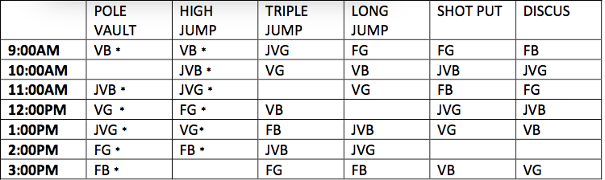
1:45 – Bus #2 leaves from WHS
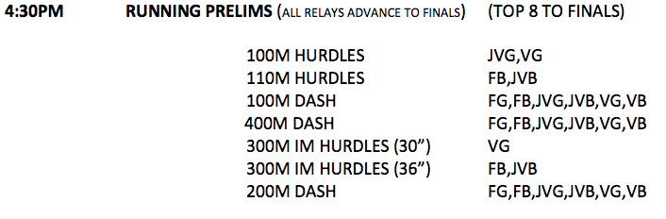

DISTRICT 25-6A TRACK AND FIELD CHAMPIONSHIPS
Thursday APRIL 5, 2018. LEANDER HIGH SCHOOL
A.C. BIBLE STADIUM 3301 S. Bagdad Rd, Leander TX 78641

Students excused from class after 6th period – 2:23
2:45 – Busses depart from WHS for Leander HS

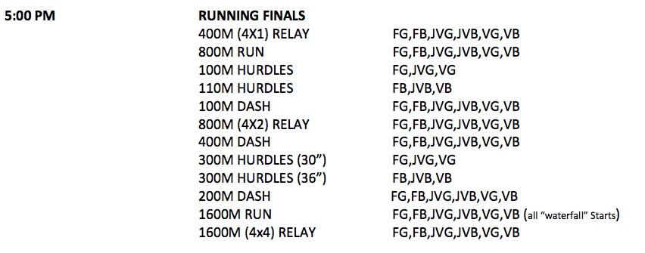

****This is finals only so all events only have 1 heat*****

