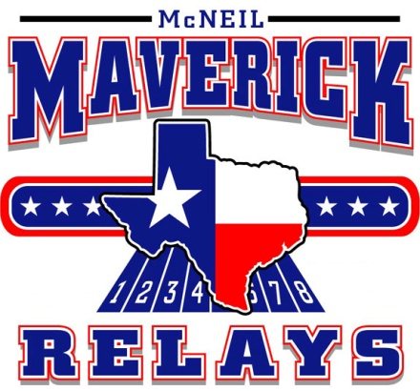
McNeil High School

5720 McNeil Rd Austin Texas 78729

Friday March 9th

Important Information
- JV and Varsity Divisions- Boys and Girls (Freshmen Boys only)
- Awards- Varsity 1st-6th, JV & Freshmen 1st –3rd

Travel Itinerary:

10:35 - All athletes will be excused after 2nd period. Any athletes that fail to attend the first two periods will be unable to complete.

10:55 – Bus #1 - Depart for McNeil High School

12:30 – Box lunches arrive

1:00 – Field Events & 3200m run Begin

1:45 – Bus #2 departs

2:15 – 4x800

2:45 – Hurdle Relay

4:10 – Start of the running events

9:00 – Completion of running events and returning to WHS

***Any student that is departing from the meet for Spring break travel plans may go, but you MUST check out with a coach.****

24th ANNUAL MAVERICK RELAYS
McNeil High School Austin Texas
FIELD EVENTS SCHEDULE
Varsity Field Events- Four Trials-No Finals
Junior Varsity & Freshmen Field Events- Three trials –No Finals
ALL FIELD EVENTS are on ROLLING SCHEDULE TIMES are APPROXIATE
VARSITY BOYS  Shot Put 1:00 Pit 1  Discus 3:00 Ring 1  Long Jump 1:00 Pit 2  Triple Jump 2:30 Pit 3  High Jump 2:30 Pit 1  Pole Vault 1:00 | JV BOYS  Shot Put 2:00 Ring 1  Discus 1:00 Ring 1  Long Jump 2:30 Pit 2  Triple Jump 1:00 Pit 3  High Jump 1:00 Pit 2  Pole Vault 1:00 | FRESH BOYS  Shot Put 3:00 Ring 1  Discus 2:00 Ring 1  Long Jump 2:30 Pit 1  Triple Jump 3:30 Pit 3  High Jump 2:00 Pit 2  Pole Vault 4:00 | JV GIRLS  Shot Put 2:00 Ring 2  Discus 1:00 Ring 2  Long Jump 3:30 Pit 1  Triple Jump 4:00 Pit 2  High Jump 3:00 Pit 2  Pole Vault 3:30 | VARSITY GIRLS  Shot Put 1:00 Ring 2  Discus 2:00 Ring 2  Long Jump 1:00 Pit 1  Triple Jump 4:00 Pit 3  High Jump 1:00 Pit 1  Pole Vault 2:00

RUNNING EVENTS
1:00 3200 meters - JV Girls
3200 meters - Varsity Girls
3200 meters - Freshmen Boys
3200 meters - JV Boys
3200 meters - Varsity Boys
4 x 800 Relay – Varsity Girls
4 x 800 Relay – Varsity Boys
4 x 100 Hurdle Relay- Varsity Girls
4 x 110 Hurdle Relay – Varsity Boys

Races will be run in this order : JV girls, Varsity girls, Freshmen Boys , JV Boys, Varsity Boys
4:10 4 x 100 meter Relay
800 meter Run
100 – 110 meter Hurdles
100 meter Dash
4 x 200 meter Relay
400 meter Dash
300 meter Hurdles
200 meter Dash
1600 meter Run
4 x 400 meter Relay

Results posted at : www.mcneiltrackxc.com
www.liverunningresults.com

McNeil High School
22MIN
17.0MI

1. Start out going northwest on Westbank Dr toward Camp Craft Rd.
Then 0.25 miles0.25 total miles
- 2. Turn slight right onto S Capital of Texas Hwy/TX-360.
Then 10.41 miles10.66 total miles
- 3. Turn left onto Research Blvd.
Then 0.04 miles10.70 total miles
- 4. Merge onto US-183 N via the ramp on the left.
Then 3.23 miles13.93 total miles
- 5. Take the exit toward Spicewood Springs Rd/McNeil Dr.
Then 0.18 miles14.12 total miles
- 6. Merge onto Research Blvd.
Then 0.34 miles14.46 total miles
- 7. Take the McNeil Dr ramp.
Then 0.04 miles14.50 total miles
- 8. Turn right onto McNeil Dr.

10. McNeil High School, 5720 MCNEIL DR .

