Islanders Splash XC Invitational
Friday & Saturday, September 22nd & 23rd, 2017
Location:
Emerald Beach Hotel
1102 S. Shoreline Blvd
Corpus Christi, Tx 78401
361-883-5731

Packing List:
- Will be distributed

Travel Schedule: -

Friday:
9:05 - Homecoming Pep Rally
Leave during 1st Period – 10:25
10:45 - Depart from Westlake & drive directly to race course
BRING YOUR OWN LUNCH
3:00 – Walk course
4:00 - Arrive at hotel & change
5:00 – Depart hotel for dinner
7:00 – Movie
9:00 - Team Meeting
10:00 - Lights out

Food Bank of Corpus Christi
826 Krill St.
Corpus Christi

Saturday:
5:30 – Wake up and & walk - Varsity
6:00 – Breakfast
7:00 – Depart from hotel – Girls
7:15 – Depart from hotel – Boys
8:15 - Varsity Girls Race
8:45 - Varsity Boys Race
9:15 – Varsity 6A Girls Race
10:00 - Return to hotel & Shower
11:00-1:00 - Corpus Christi food bank – Service Project
1:00 – Return to WHS & eat lunch on way home

Race Course
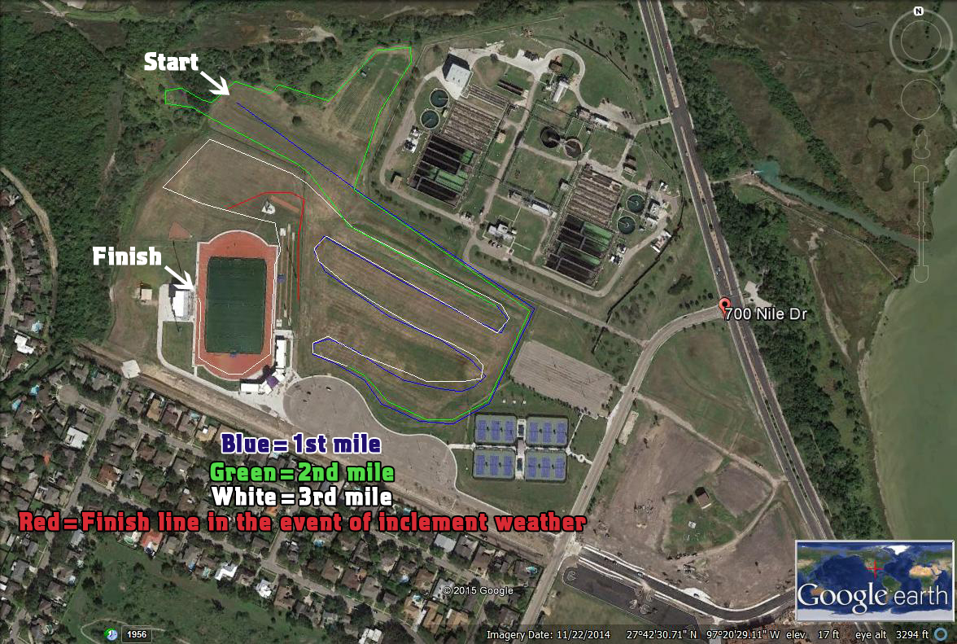
Directions to Hotel - 102 S Shoreline Blvd, Corpus Christi, TX 78401 - 3HR 29MIN - 197MI
Then 3.07 miles3.32 total miles
- 3. Take TX-360/S Capital of Texas Hwy toward Bastrop.
Then 0.56 miles3.87 total miles
- 4. TX-360/S Capital of Texas Hwy becomes US-290 E/TX-71 E.
Then 2.20 miles6.08 total miles
- 5. Merge onto I-35 S toward San Antonio.
Then 26.93 miles33.01 total miles
- 6. Take EXIT 204A toward TX-123 E/TX-820 W/Seguin.
Then 0.20 miles33.35 total miles
- 8. Turn left onto S Guadalupe St/TX-123/TX-82 Loop. Continue to follow TX-123.
  - TX-123 is 0.1 miles past S L B J Dr
  - If you reach Patton St you've gone a little too far
Then 69.11 miles102.46 total miles
- 9. TX-123 becomes TX-80/N Highway 123.
Then 1.93 miles104.38 total miles
- 10. Turn left onto US-181 S/N Sunset Strip St. Continue to follow US-181 S.
Then 62.59 miles166.98 total miles
- 11. Stay straight to go onto TX-89.
Then 3.62 miles170.60 total miles
- 12. TX-89 becomes US-181 S.
Then 15.18 miles185.78 total miles
- 13. Merge onto US-181 S/TX-35 S via the ramp on the left toward Corpus Christi.
Then 9.67 miles195.45 total miles
- 14. Take the exit on the left toward Bayfront/Shoreline Blvd/C.C Museum.
Then 0.13 miles195.58 total miles
- 15. Merge onto Twigg St.
Then 0.32 miles195.90 total miles
- 16. Turn right onto N Shoreline Blvd.
  - N Shoreline Blvd is just past N Water St
Then 1.15 miles197.05 total miles
- 17. Turn slight right onto Ocean Dr.
  - Ocean Dr is just past Furman Ave
Then 0.12 miles197.17 total miles
18. 1102 S SHORELINE BLVD.

700 Nile Dr, Corpus Christi, TX 78412 - 12MIN - 6.9MI

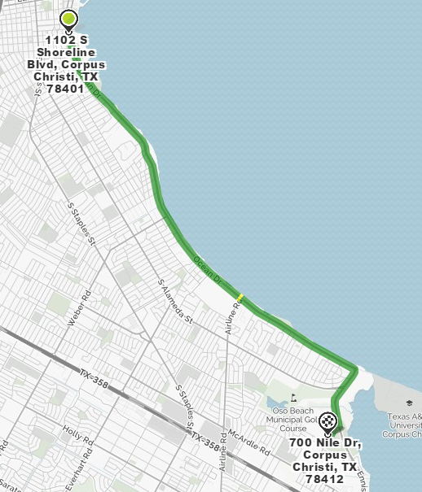
1. Start out going south on Ocean Dr toward Craig St.
Then 5.80 miles5.80 total miles
- 2. Turn right onto Ennis Joslin Rd.
  - Ennis Joslin Rd is just past Country Club Dr
Then 0.93 miles6.73 total miles
- 3. Turn right onto Nile Dr.
  - Nile Dr is 0.3 miles past Del Oso Rd
  - If you reach Pharaoh Dr you've gone about 0.4 miles too far
Then 0.18 miles6.91 total miles

4. 700 NILE DR.

